## Part 2 ****Matlab Excercises****

**2.1 Warm up problem with Standard Kalman Filter**

**Question 1**

According to the equation $x_{k+1}$**= ${Ax}_{k}$ +B $u_{k}$ + $ε_{k}$**, $ε_{k}$ should have the same dimension as the result of ${Ax}_{k}$ +B $u_{k}$, which is two dimension(2*1 matrix). And $δ_{k}$ should have the same dimension as the measurement $z_{k}$, which is one dimension.

To define a uniquely white Gaussian, we need to define mean value **μ** and a covariance $σ^{2}$. The covariance would be a 2*2 matrix Σ.

**Question 2**

|  |  |
| --- | --- |
| Variables | Meaning |
| x | The actual state of system |
| xhat | The estimate state of system |
| P | Estimate error covariance matrix. |
| G | Identity matrix for process noise |
| D | Identity matrix for measurement noise |
| Q | Covariance matrix of noise in the measurement model |
| R | Covariance matrix of process noise |
| WStdP | The noise weight of position in the simulation |
| WstdV | The noise weight of velocity in the simulation |
| vStd | The noise weight of measurement in the simulation |
| u | Control signal(The acceleration in the system) |
| PP | The storing matrix for the position during the KF process in prediction |

**Question 3**

The normal image, the image with the process noise increased by 100 times and the image with the measurement noise increased by 100 times are shown in the following figure respectively. I think the former will increase the Kalman gain, while the latter will decrease the Kalman gain.

By comparison, we can find that when the process noise is increased, the Kalman gain of the system becomes larger. This is because the system is more dependent on the observed data rather than the predicted data. At the same time, the prediction speed has become very unstable. I think this is because a relatively high Kalman gain will cause a large amount of change in the prediction each time it is updated. When we increase the measurement noise, the system will rely more on the data predicted by the model, so the Kalman gain will become smaller. However, due to the lack of limited observational data to update, the system has a larger position error. Compared with Figures 1 and 2, the position cannot always converge to near 0, but is maintained at about 0.4. This is in line with my prediction.

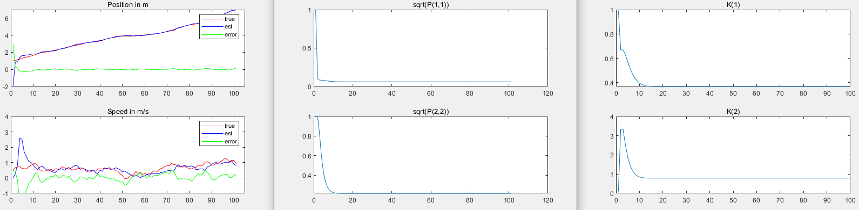

Figure 1: normal system

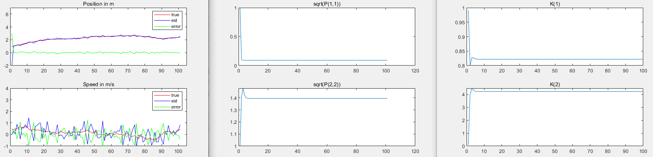

Figure 2: system with 100 times process noise

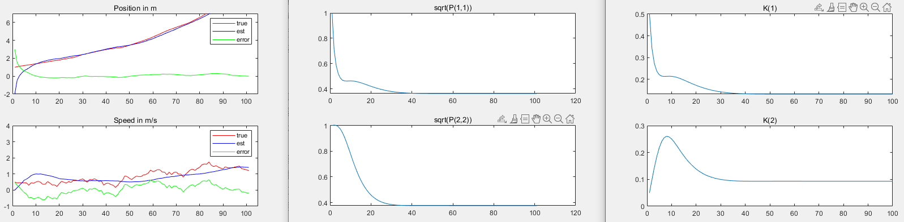

Figure 3: system with 100 times measurement noise

**Question 4**

From Figure 4, we can see that when P becomes very large, the system will rely heavily on observations at the beginning, so the Kalman gain will become very large at the beginning, which makes the system converge very quickly. On the contrary, when P is very small (Figure 5), the system will believe the predicted value more, the value of Kalman gain will decrease, and the system will slow down to converge to near the actual value, but the error will eventually be small.

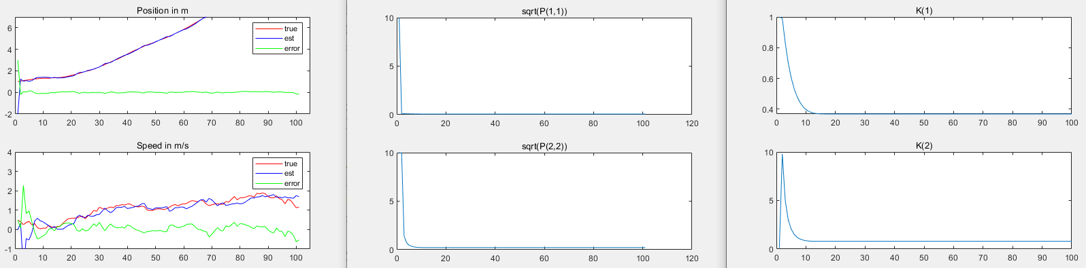

Figure 4: Increase P to 100

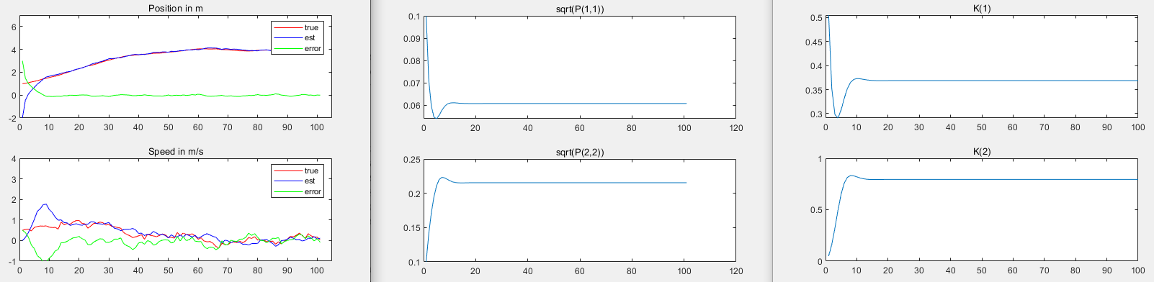

Figure 5: decrease P to 0.01

At first I increased the initial value of xhat by 100 times, but this did not bring any change, so I increased it to 1000 times, which is [1000, 500], as can be seen from Figure 6, because the initial value The deviation is large, so at first the Kalman gain is also large, and it takes a relatively long time for the system to converge to near the actual value.

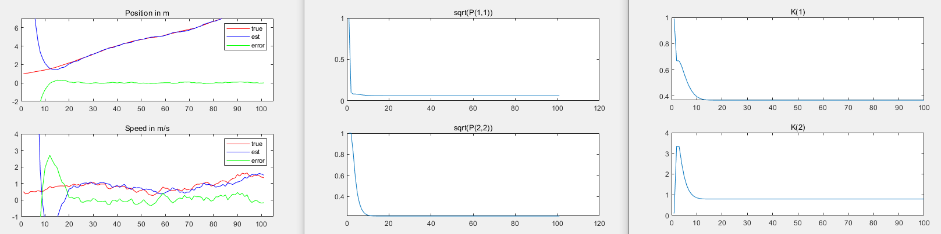

Figure 6: Increase Xhat to [1000, 500]

**2.2 Main problem: EKF Localization**

**Question 5**

The first equation of (2) is responsible for both update and prediction.

And the first equation of (3) is responsible for update, and second equation of (3) are responsible for prediction.

**Question 6**

Yes I think it’s a valid assumption. Since each measurement is only related to the state of each time, and the noise is Gaussian, it has nothing to do with the last or next measurement. So it’s independent.

**Question 7**

The bounde of $δ_{m} is [0,1]$ as it is a probability. Increase $δ_{m}$ will cause $λ_{m}$ to increase. When the measured value is unreliable, $λ_{m}$ should be reduced so that more outliers are rejected. And when the measurements we get from the map are reliable, there should be fewer outliers, so we can increase by $λ_{m}$.

**Question 8**

In sequential update, since the value of the next measurement is always estimated on the basis of the previous measurement update, the first impact always exists. If there is an error in the first measurement or there is a lot of noise, it may cause the covariance matrix to decrease, which in turn affects St, j and Mahalanobis distance, resulting in unreasonable rejection of outliers.

**Question 9**

There are many zero matrices in matrix multiplication. We can use the symmetry in the covariance and uncertainty matrix to reduce the computational complexity of the algorithm

**Question 10**

The dimension of $\overline{v_{t}}$ is 2nx1 and in the sequential update is 2x1.

The dimension of $\overline{H_{t}}$ is 2nx3 and in the sequential update is 2x3.

That means the batch update will use all features to decide outliners, which brings more calculations.

**2.3 Simulating data sets**

**2.3.1 Dataset1**

In the result of dataset 1 we can see that on all dimension the mean absolute error are less than 0.01(m, rad), which is satisfied the requirement.

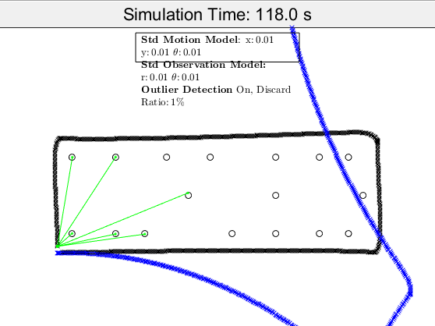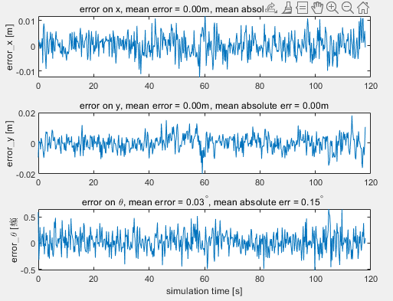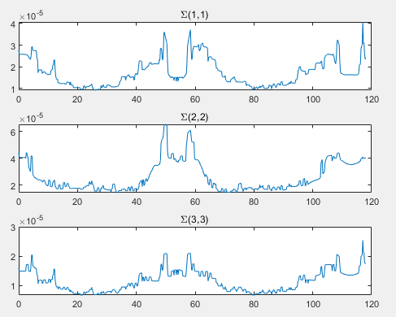

Figure 7: Result of dataset1

**2.3.2 Dataset2**

In the result of dataset 2 we can see that on all dimension the mean absolute error are less than 0.06(m, rad), which is satisfied the requirement.

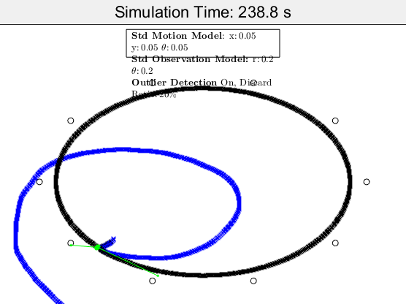

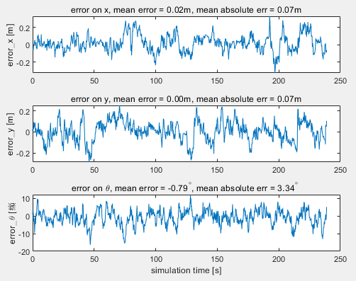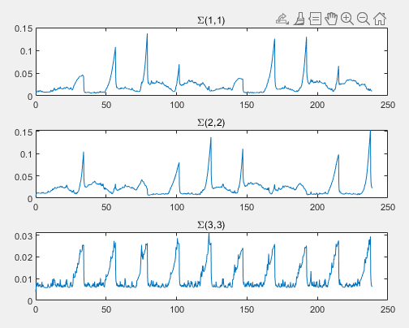

Figure 8: Result of dataset2

**2.3.3 Dataset3**

In the result of dataset 3 we can see that on all dimension the mean absolute error are less than 0.01(m, rad), which is satisfied the requirement.

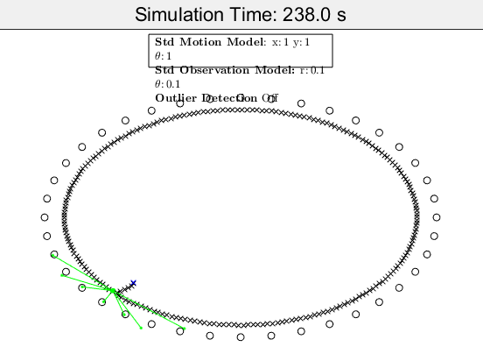

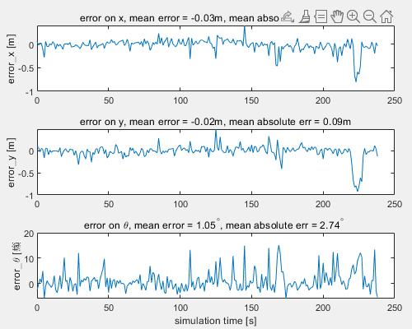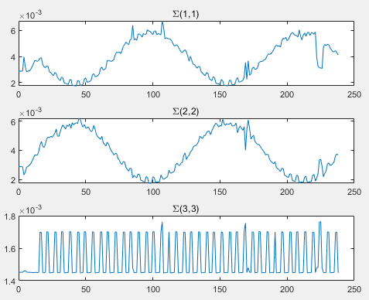

Figure 9: Result of dataset3